DATA ANALYSIS-
1)Top Items sold every year –
- Year 2022-
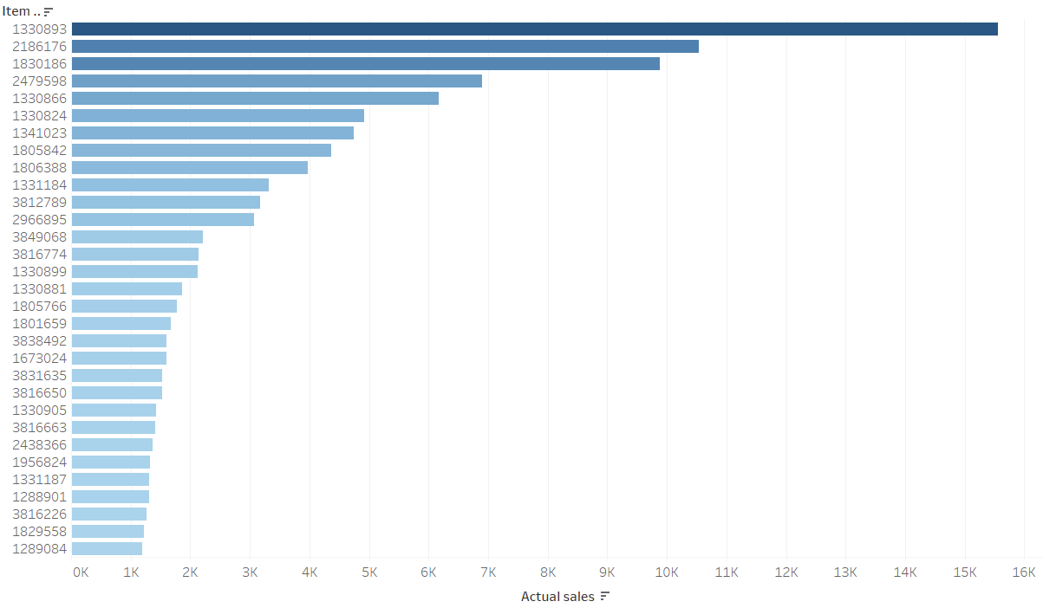
- Year 2023-
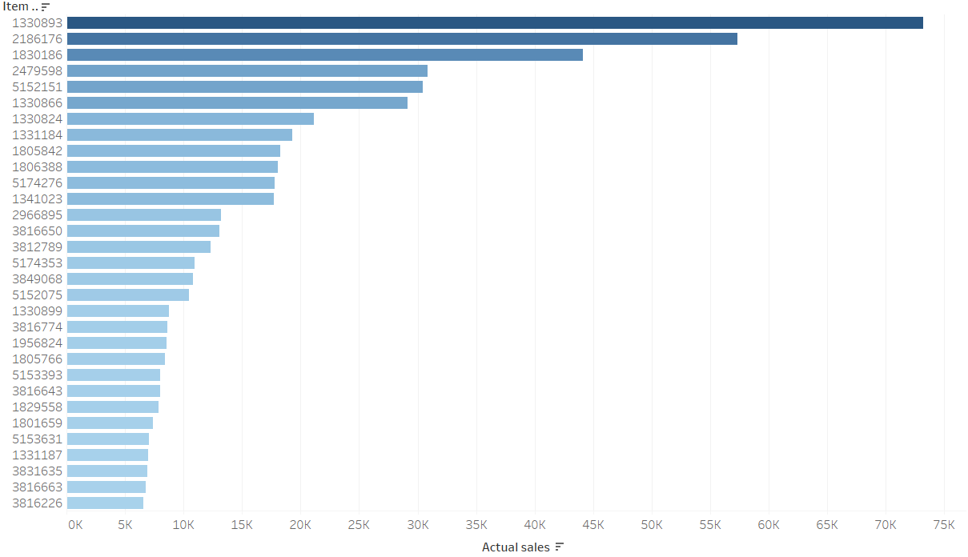
- Year 2024-
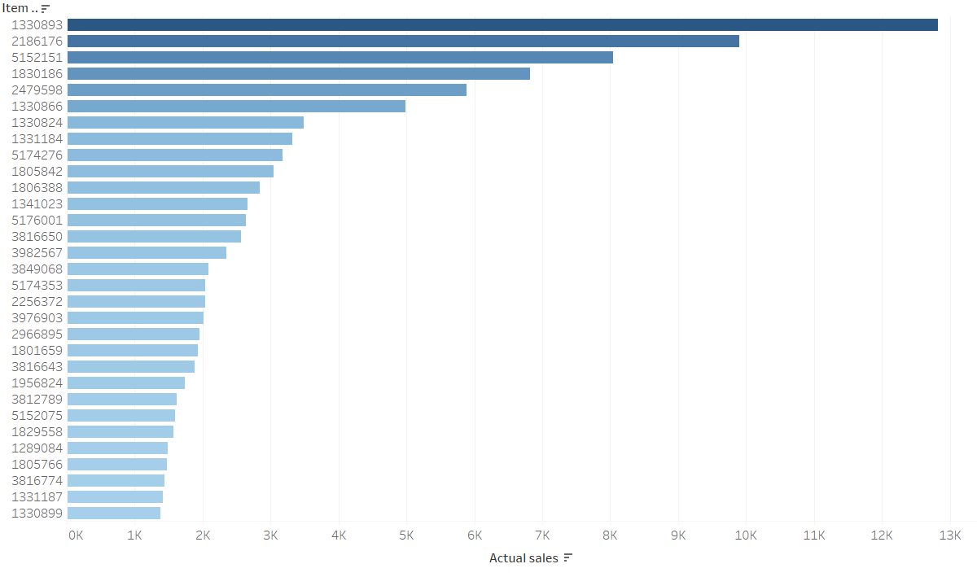

2)
- Comparison between forecasted values and actual values -

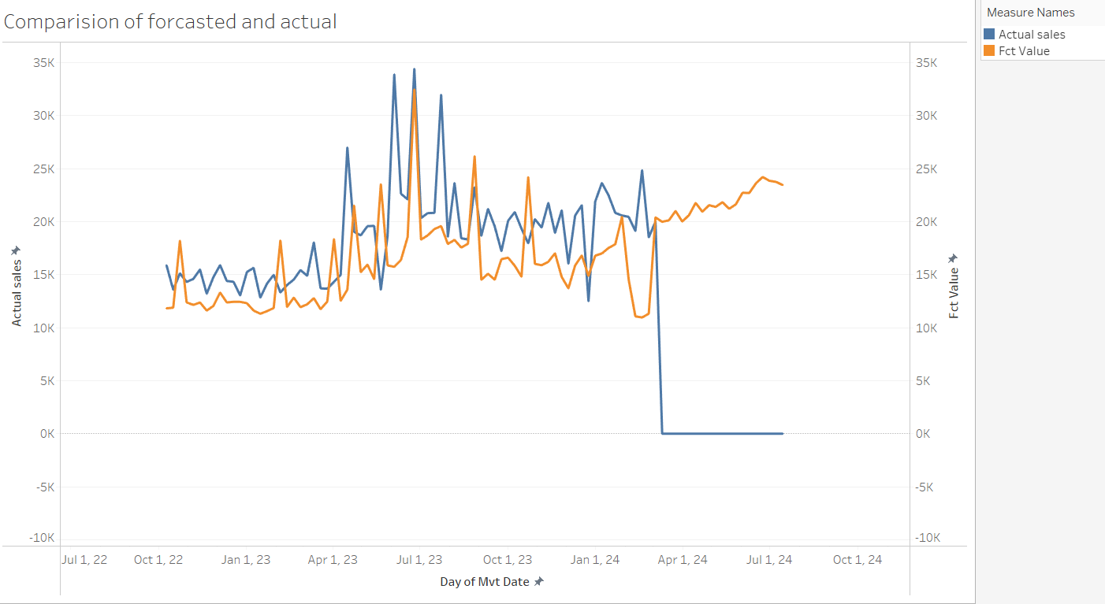

3)
- Number of items sold in holidays.
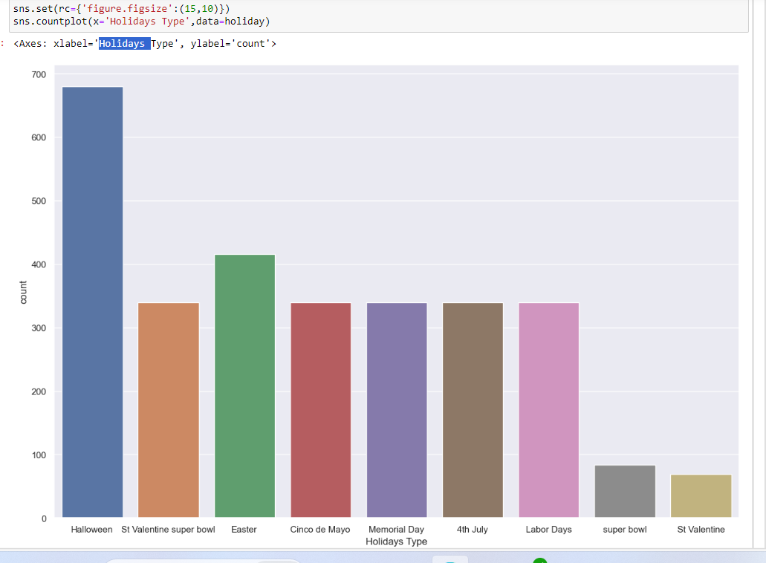
- Total sales in holidays.
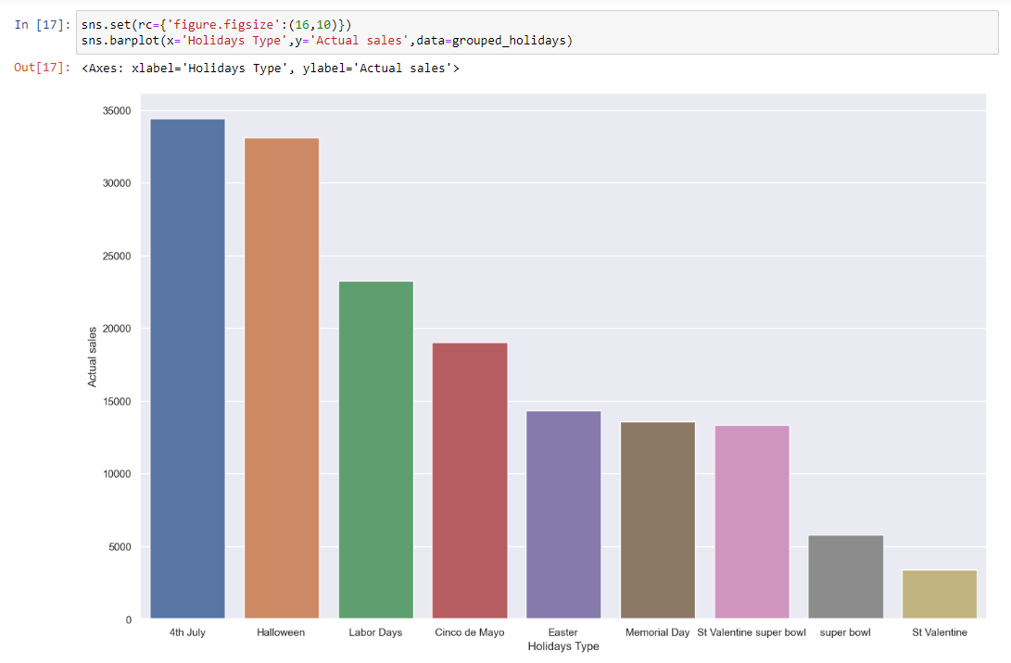
Conclusion –
The number of items sold on Halloween are more, but the total number of sales are more on 4th July compared to Halloween.
Accuracy
- Accuracy using WMAPE-
Formula-
WMAPE= SUM( ABS( [Fct Value] - [Actual sales] )) / SUM([Actual sales])
Accuracy= 1-[WMAPE]

- Accuracy at item level

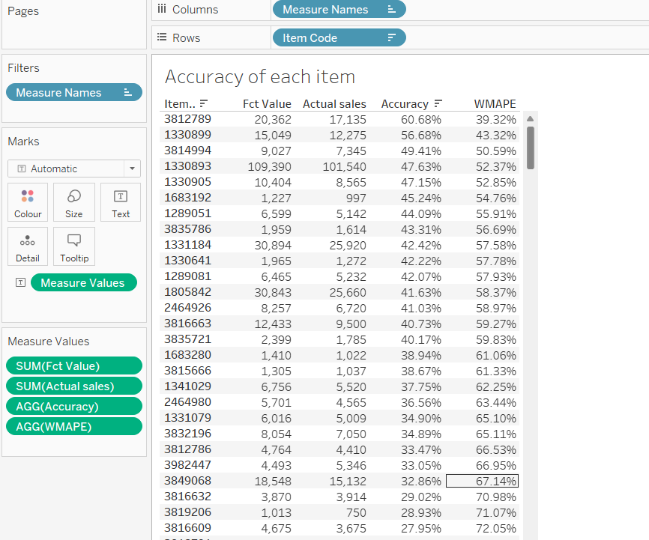

- Accuracy of each week in 2022-
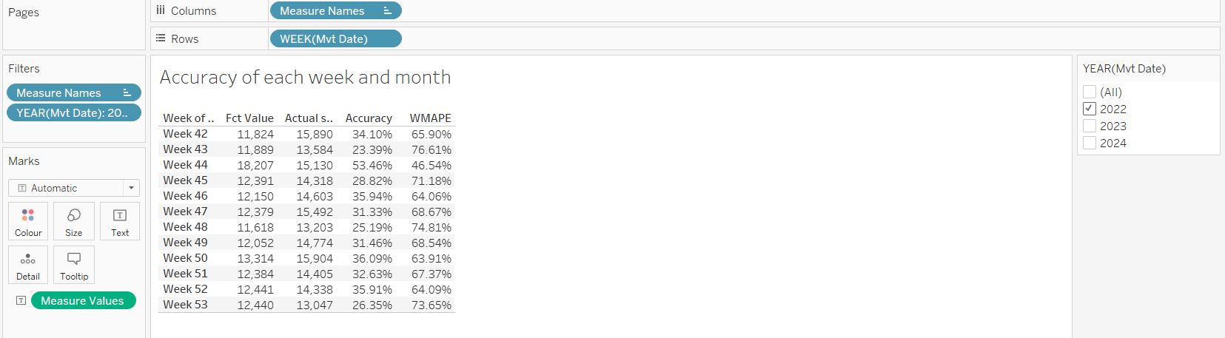

- Accuracy of each week in 2023-
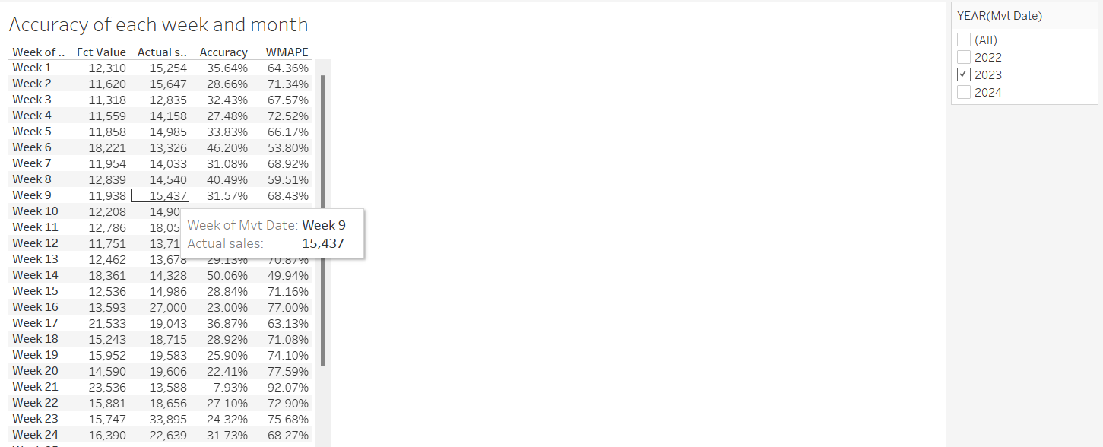

- Accuracy of each week in 2024
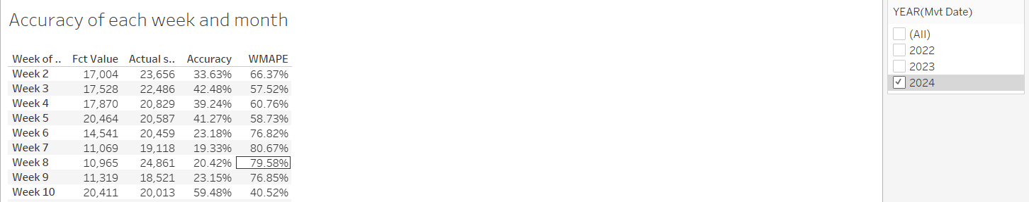

- Accuracy of each month in 2022-
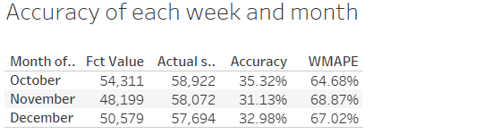

- Accuracy of each month in 2023-
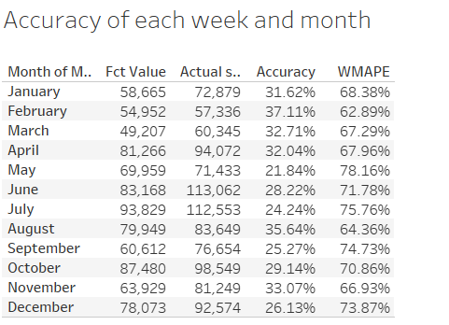

- Accuracy of each month in 2024-
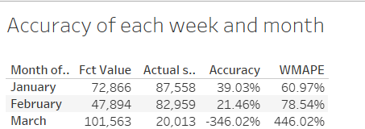
- Accuracy of each item in each week of 2022

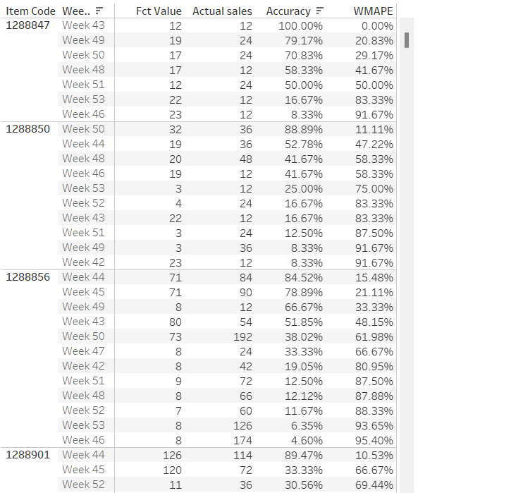

- Accuracy of each item in each week of 2023
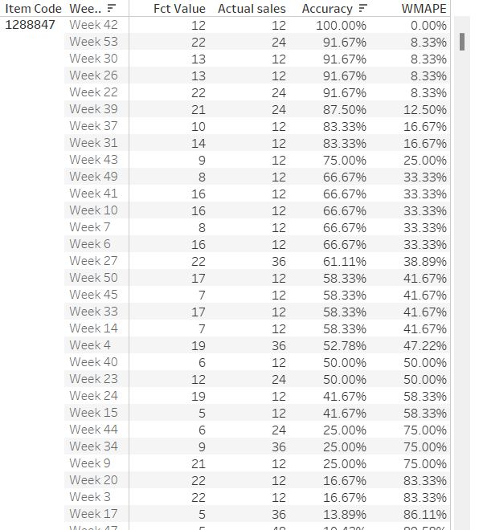

- Accuracy of each item in each week of 2024-
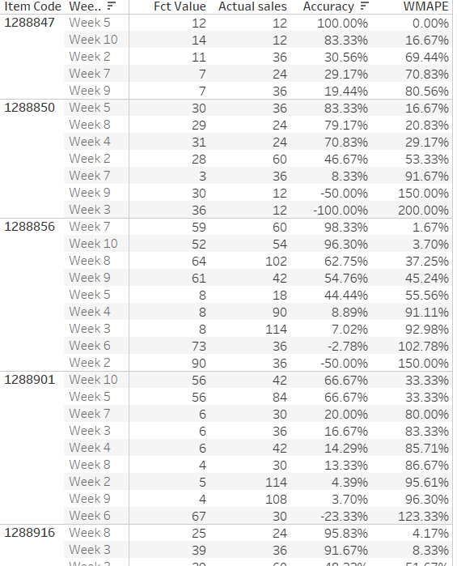

- Accuracy using SMAPE-
Formula-
SMAPE - AVG(ABS([Actual sales] - [Fct Value]) / ((ABS([Actual sales]) + ABS([Fct Value])) / 2))
Accuracy = 1-[SMAPE]
- Accuracy of each item at week level
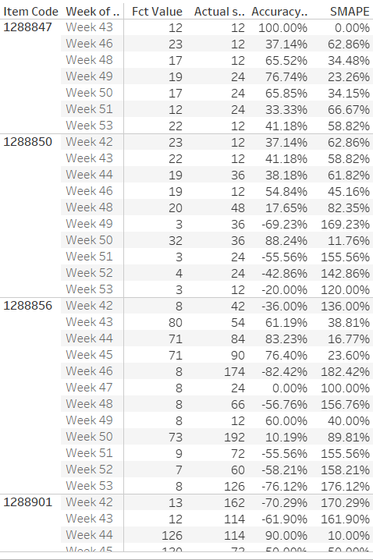

Conclusion –

1)WMAPE
Fval=5
Aval=10
(Forecasted is less than actual)
WMAPE= abs(Fval-Aval) / (Aval)
= (5-10)/10
= 5/10
=50% error
=50% accuracy

Fval=10
Aval=5
(Forecasted is more than actual)
WMAPE= abs(Fval-Aval) / (Aval)
= (10-5)/5
= (5/5)
= 100% error
= 0% accuracy

Top 10 items sold –
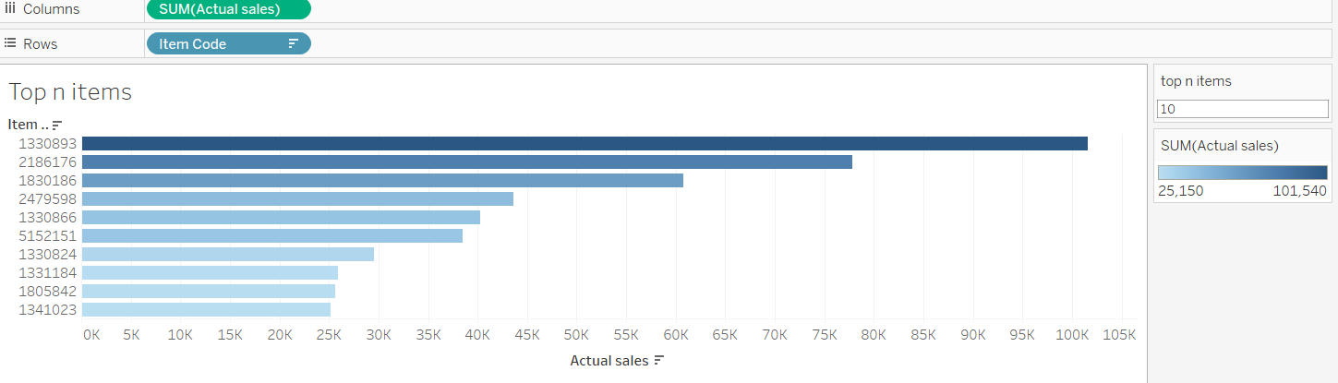
Top 5 items sold-
